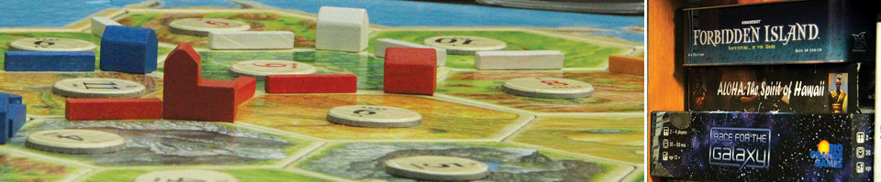

Photo Credit: [Hampshire Game Library](http://gamelibrary.hampshire.edu)

Design A Game

**Part 1** Due in class on **2/10**

**Part 2** Due in class on **2/19**

**Part 3** Due before class on **2/26**

**Part 4** Due before class on **3/12**

**Part 5** Due before class on **4/2**

**Part 6** Due before class on **4/16**

**Final** Due before class on **4/30**

For this project, you will design your own original board game. This assignment is intended to be fun, and to help you increase your skills in the following areas:

* Designing a game from start to finish
* Playtesting
* Writing game rules
* Critically analyzing your own work
* Providing thoughtful feedback to others
* Reaching final polish and sustaining effort

**Constraints**

Because I believe it will provide maximum educational value to all of you, please work within these constraints:

* An analog game
* 30 – 90 minute play time for one game
* Some balance of luck and skill, usually more skill-based
* Highly replayable

Basically, please make something in the general ballpark of the games we’re playing for the Weekly Gameplay project. If you would like an exception to any of the above constraints, simply get permission from Ira in advance.

**Supplies**

This is a friendly reminder that Ira can provide material supplies for your game making needs. This is partially what your materials fees are paying for. Email me any time with requests. <http://irafay.com/classes/Supplies>

**Part 1**

By the deadline, prepare a 60 second, single-slide presentation on your game. Obviously you won’t know a lot of the details yet, but I’m expecting some overview of what you’re planning making.

We will use this shared presentation document:

<https://docs.google.com/presentation/d/1z9ZtMsMMJsD2QSQtQfzVsSxWF3r3ZAexZxcneD_ra3U>

1) Copy and paste the Template Slide.

2) On the new slide, enter your information.

3) Each person gets exactly one slide.

**Part 2**

By the deadline, bring a playable prototype of your game to class. You should have written rules and any materials that you need to play your game. Ensure that you are prepared to take detailed playtest notes.

**Part 3**

There are three sub-parts:

**A)** Before you start any playtests, design a simple survey for your playtesters to complete. It can be online or a paper form. Use it for this whole project, and modify it as needed later in development. Include quantitative questions (What would you rate the game on a 1 to 5 scale?) and qualitative questions (What could be most improved about the game?).

**B)** Complete at least 2 playtests of your game and take careful notes. You are practicing your observation and writing skills in the Weekly Gameplay project, so put those skills to use on your own game too!

During/after each playtest, record the following information:

* Who played, what rules version were you using, when you played.
* Length of game, final scores, other outcome details.
* What was most fun, least fun, most confusing, least confusing, etc.
* At least one picture of the playtest in-progress.
* Anything else of note.
* Rules that you intend to change based on the playtest.
* The survey results from each player.

**C)** Create a blog for your game on BGG and include the words “designer diary” in the title of your blog. Here’s the direct link to create a blog:

<https://www.boardgamegeek.com/blog/create>

Post at least once to your blog. The post should be at least as good as a session report from the Weekly Gameplay project. Include at least one picture. The topic of the blog post is up to you, but it should relate to your Design A Game project in some way. Possible topics for your post include: your brainstorming process, what inspired you to choose your game topic/genre/mechanics, your biggest fear about the game, what excites you most about the game, a playtest report, etc.

**Part 4**

By this deadline, complete at least 4 playtests and have at least 3 posts on your designer blog. Every blog post should include at least one picture.

Possible blog topics include:

* What inspired you to choose your game topic/genre/mechanics
* Your biggest challenge with the game so far
* What excites you most about the game
* A comparison to similar games or games that informed your design
* A detailed playtest report
* The survey you’re using to gather information from your playtesters
* An analysis of a particular mechanic
* A high level overview of your themes from playtest feedback so far
* The current rules, and areas of possible future revision
* Discussion of iconography and art in your game
* The context of your game within society and culture
* Anything else interesting and well-written

**Part 5**

By this deadline, complete at least 7 playtests and have at least 6 posts on your designer blog. Every blog post should include at least one picture. See above for blog post ideas.

Ensure that you have at least one blog post that includes the current rules. I would expect that the highest quality games will have many more than the listed number of playtests.

**Part 6**

By this deadline, complete at least 9 playtests and have at least 8 posts on your designer blog. Every blog post should include at least one picture. See above for blog post ideas.

Ensure that you have at least one blog post that analyzes your playtest feedback so far. I would expect that the highest quality games will have many more than the listed number of playtests.

If you intend to make a polished prototype of your game, consider getting higher quality or custom materials for your game now. I have some available at <http://irafay.com/classes/Supplies>, and you can order custom parts from many websites. I like: <http://www.printplaygames.com> and they have apparently partnered with <http://admagic.com>.

**Final**

By this deadline, complete at least 11 playtests and have at least 10 posts on your designer blog. Every blog post should include at least one picture. See above for blog post ideas. I would expect that the highest quality games will have many more than the listed number of playtests.

Provide Ira with a game logo and/or flier for your game, suitable for printing in color and displaying proudly. I will be printing a variety of game images/fliers and posting them near my office so prospective students can have a better sense of game design at Hampshire.

Submit yourself as a game designer here: <https://boardgamegeek.com/item/create/boardgameperson>

After you exist in the system as a game designer (it takes a couple minutes), submit your game to BGG here:

<https://boardgamegeek.com/item/create/boardgame>

Congratulations!

Original assignment designed by Professor Ira Fay.